Make a SSB transceiver with the Choc Perf Board
Adam Rong, BD6CR

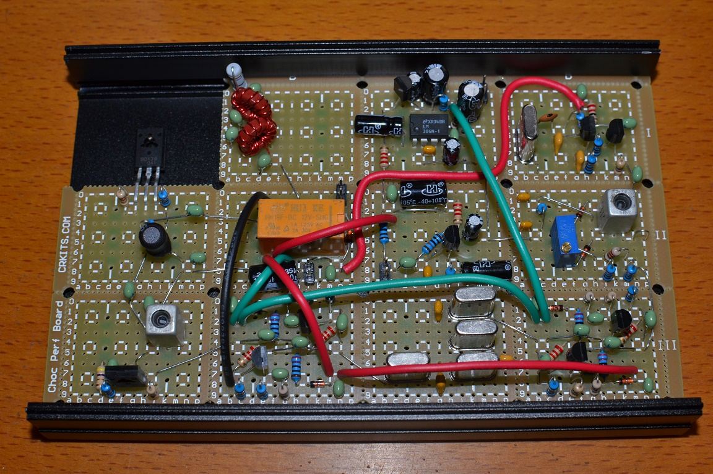
The Knobless Wonder is a SSB radio with one frequency without tuning or volume knobs designed by VK3YE. It is much like a DSB radio adding a crystal filter, as shown as above. It also uses several bi-directional amplifiers just like BITX. The designer likes dead bug building style, but my way is to use the Choc Perf Board from http://crkits.com. This perf board is specially designed by BD6CR several years ago to facilitate RF circuit experiments. The perf board consists of several units with the same pattern. In each unit, there are total 12 4-pad pattern, very convenient for discrete components. In order to be compatible with IC’s, pin headers, and relays, two rows of pads are added. The most convenient design is to fit in 7mm x 7mm IF transformers (shielded coils) like FCZ-7S series by FCZ labs in Japan or DIY7 series widely used by CRKITS.COM. In order to support that, total 6 big pads are added into each unit. Grounding is around each unit and stamp holes are added to be easily break apart or used for shielding can installation. We call it Choc Perf Board because it is much like a big bar of chocolate that you can easily break into small bars.

Compared with the regular perf board with all independent pads, grounding around each unit in Choc Perf Board provides isolation between RF circuit stages and also very near and short grounding. The pre-wired pads can meet most of the wiring requirement in discrete component circuit so it is quite convenient. It has good RF performance and good for HF band receivers and transmitter of a few watts. In order to make the final project look better, it is compatible with a metal case used for KN-Q7A transceiver. With the face plates and controls, it makes a complete homebrew radio.
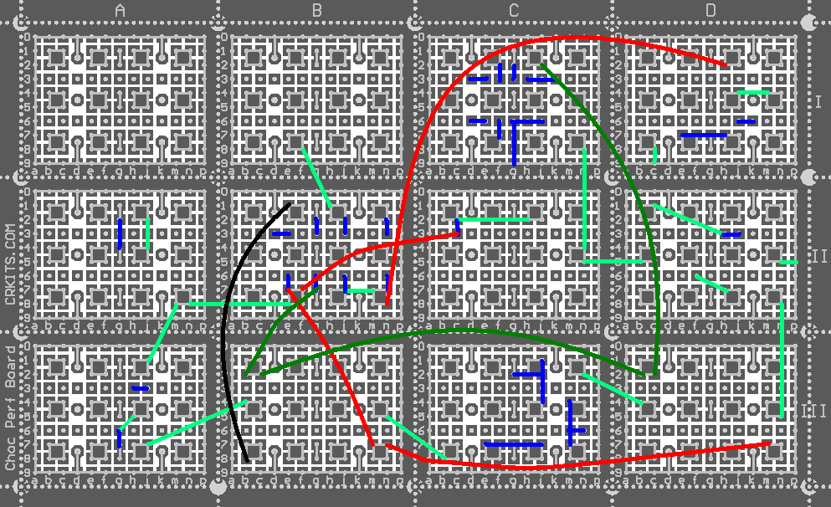
The Choc Perf Board is a single layer board, so it needs a few jumper wires. Jumper wires can be classified into several types: power lines can be a few colored insulated solder wires (like red, deep green and black wires as shown in the diagram) on the component side; inter-unit signal connection can be an unused component lead, solder wire, or a thin shielded coaxial cable (like the light green wires as shown) on the component side; intra-unit connection can be an unused component lead on the component side, or if it is very nearby, it also can be a solder bridge connection or solder bridge connection with the help of an unused component lead (like the blue wires as shown).

In the photo on the top of this article, we took apart the upper left unit for the space of the heat sink installation for the transmitter final stage. Because there is no plated via or hole in the single layer PCB, with high temperature soldering or extra force, the pads are relatively easier to peel off, especially for the independent pads. To play safe, it is advised to cut through the copper foil using a knife first and then mildly break apart the unit with a pair of pliers.

If you build your project without reference wiring diagram, you will need to study the schematic and make a good planning of the layout on the Choc Perf Board. First, plan each stage on the whole board to make each inter-unit connection as short as possible, especially for RF signals (and if you have to use long wires to connect RF signals, consider a coaxial cable to avoid noise radiation or pick up), and don’t make the transmitter final stage loop back to the front stages to avoid self-oscillation. Also, local oscillator stage is quite sensitive because it is easy to radiate or pick up interference to make it unstable, so it is advised to keep away from the transmitter final stage as well. Sometimes, in order to make it easier for perf board building, you will need to modify the schematic a little bit, like interchange of components in serial connection, adding of a capacitor for AC coupling, adding of a small value resistor for DC connection, change of polarity or phase of a few components like transformers, adding or removing a few decoupling capacitors depending on the actual layout and wiring. It is observed that the Choc Perf Board is not as friendly with audio circuits as the RF circuits, because the requirement of the grounding in the audio circuits is not the same as the RF circuits, so you will need to take cautions to wire the audio stages to make it stable.

Once you are familiar with the Choc Perf Board building, you can challenge more complicated projects like a complete BITX-40. Here I show you the planning of my two boards and they still can be installed into the KN-Q7A metal case, one on bottom case and the other on the top case. My BITX-40 covers the whole 40-meter band and transmits 5 watts with clear transmit audio, and the receiver is quite sensitive. I also built a FM transmitter of two transistors in one unit and it works quite well too.


